NT DM Escape Room Instructions

Students will be divided into groups of 10 – 12.

The same escape room will be going in each room. One teacher will be in each room as the “host.”

The Story

Bishop Johnathon Davies was asked to give a talk at the Interfaith Leadership Summit in DC. Unfortunately, Bishop Davies has just arrived at the summit only to realize that he has forgotten his notes and phone in his office. He can’t remember his speech but thinks that if he could remember the main scripture reference, he will be able to jog his memory. He borrows a phone and calls the church. The youth are meeting for mutual and one of the Deacons answers the phone. The Bishop asks the Deacon to round up some youth and go to his office and the scripture. He warns the group that his thought process and note taking methods can be a bit eccentric, but if they look around and follow things through, they should be able to find his “Notes” which will have the scripture listed. The service starts in 30 minutes, so he needs it before then!

Puzzle #1
For this puzzle several bibles should be set up around the room. Also Post-it notes for John 7:17 w12 (J 7:17 w12), 2 Thessalonians 2:2 w17 (2T 2:2 w17). James 1:5 w3 (J 1:5 w3), and Revelation 20:12 w11 (R 20:12 w11) need to be prepared. These they should be scattered around the room in plain sight. Finally for this puzzle there needs to be a box in the room. The box should have a large note on it that states “Locked! Password needed.” The room host should explain the box is locked with voice recognition and it requires a particular code word to open. It will also be helpful if a white board or some other sort of large writing surface is available for participants to take notes. Participants will need to first look around the room and find the post-it notes with DM scripture references on them. The participants will need to figure out three separate elements to solve this puzzle. First, they will need to figure out that the post-it notes have DM references and the “w” followed by a number refers to a specific word in the verse. Second, they will need to figure out that for the words to make sense they need to be put in the order they appear in the NT. When this is done the words reveal a sentence (“The word of God”). Finally, the participants need to figure out what the statement is referring to (scriptures). The word the sentence is referring to is the secret word that will open the box. The students need to approach the box and say the correct word. When they do the room host should open the box.

Puzzle #2
Inside the box participants should find a picture and magnifying glass. There should be 5 other pictures and some magnifying glasses spread throughout the room. The participants will need to figure out four separate elements to solve this puzzle. First, they will need to gather all 6 pictures. Second, they will need to figure out that the pictures need to be put in the order they happened in Christ’s life. Third, they will need to use the magnifying glasses to find the numbers hidden in the pictures. Fourth, they need to figure out that the hidden numbers (152022) are a reference to 1 Corinthians 15:20-22 and are the combo to the combination lock on the box in the room.

Puzzle #3
Inside the box the participants should find two things. They should find an index card with a “3” written in red sharpie. They should also find a puzzle piece. First, you will need to acquire a blank Jigsaw puzzle that is as close to twenty-five pieces as possible. Going left to right, and top to bottom, write the books of the New Testament DM references on the puzzle. On the back of the puzzle you will need to write the following on the back in black sharpie: Phone Password Hint: James 5 FN A. You will also need to put on the back of the puzzle in red the number “15”. This number should be circled to indicate that it is different from the phone password clue. The rest of the puzzle pieces should be shattered around the room. This puzzle is a literal puzzle and the participants will have to assemble it. They will need to figure out the easiest way to do so is put the DM topics together in order. Hang a copy of the DM list in the room. Once they have assembled the puzzle, they will need to flip it over to get the phone password hint. Once the participants put the puzzle together and find the clue, they will need to look up James 1:5 footnote A. This footnote references D&C 42:68 & JS-H 1:11. The password is just the numbers in this footnote (4268111)

Puzzle #4
The room facilitator will need to use a smartphone (their own or borrow one). It should be placed in the room before hand and it should be password protected with the password 4268111. In the Notes app there should be a single note that reads 2 Timothy. The cell phone should be setting in the room somewhere out of the way but in plain sight. If participants have not yet found it they will need to. Once they unlock the phone, they will need to remember from the introduction that “most of the scripture” is in the Bishop’s notes. In the notes app they will find 2 Timothy Note. At this point they will need to realize the two red numbers on the back of the puzzle are also part of the scripture reference. The final task the participants need to do is look up the scripture. 2 Timothy 15:3 does not exist, so the scripture they are looking for is 2 Timothy 3:15. If they can find this answer before thirty minutes is up, they win!

The Story

Bishop Johnathon Davies was asked to give a talk at the Interfaith Leadership Summit in DC. Unfortunately, Bishop Davies has just arrived at the summit only to realize that he has forgotten his notes and phone in his office. He can’t remember his speech but thinks that if he could remember the main scripture reference, he will be able to jog his memory. He borrows a phone and calls the church. The youth are meeting for mutual and one of the Deacons answers the phone. The Bishop asks the Deacon to round up some youth and go to his office and find the scripture. He warns the group that his thought process and note taking methods can be a bit eccentric, but if they look around and follow things through, they should be able to find his “Notes” which will have most of the scripture listed. The service starts in 30 minutes, so he needs it before then!

Locked!
Verbal codeword required
Locked!
Verbal codeword required
Locked!
Verbal codeword required
Locked!
Verbal codeword required

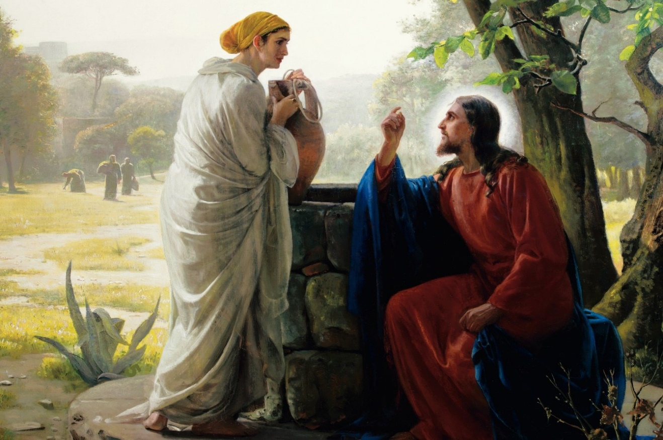
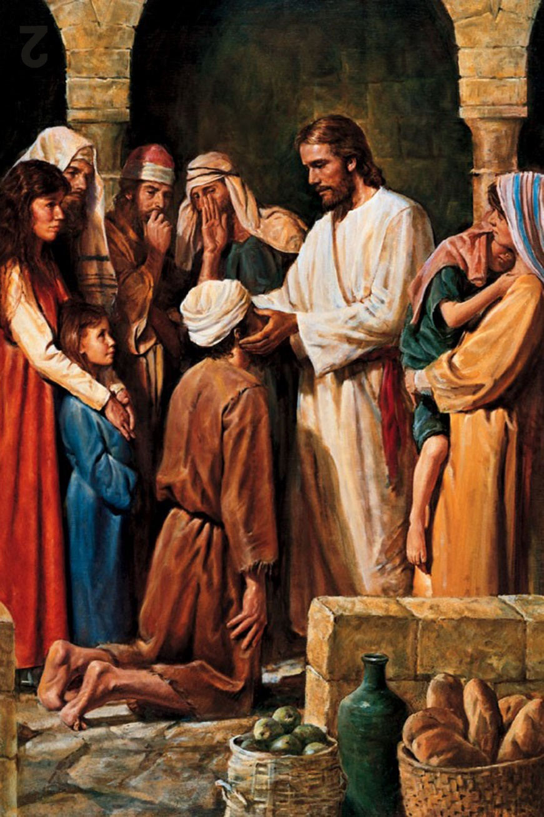

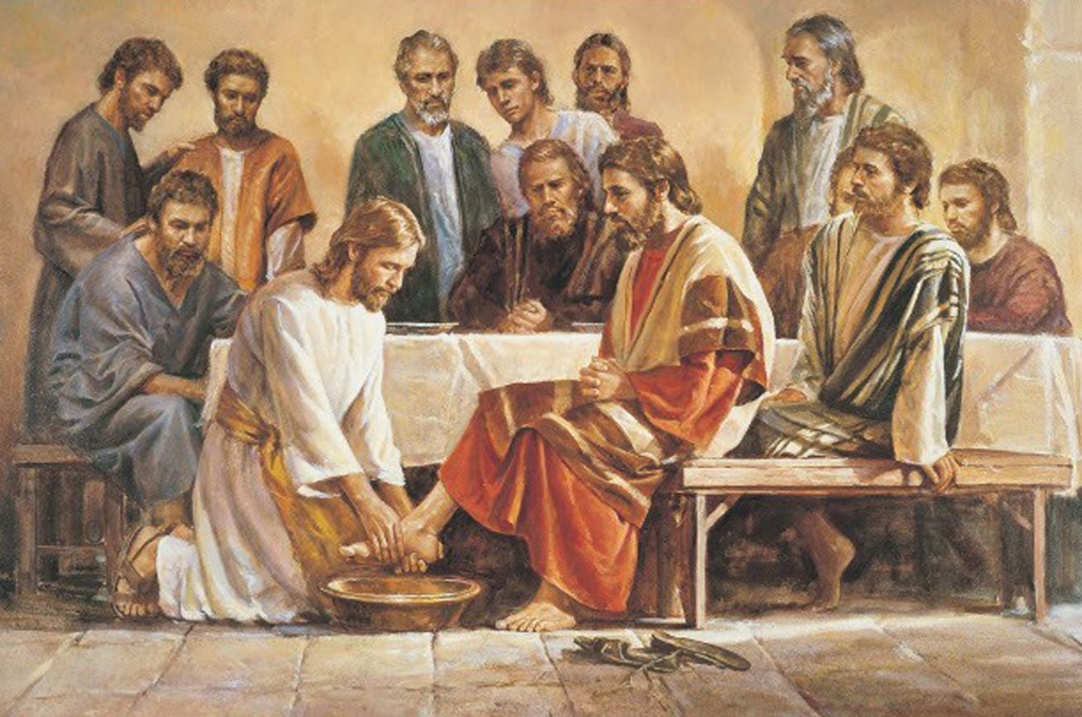

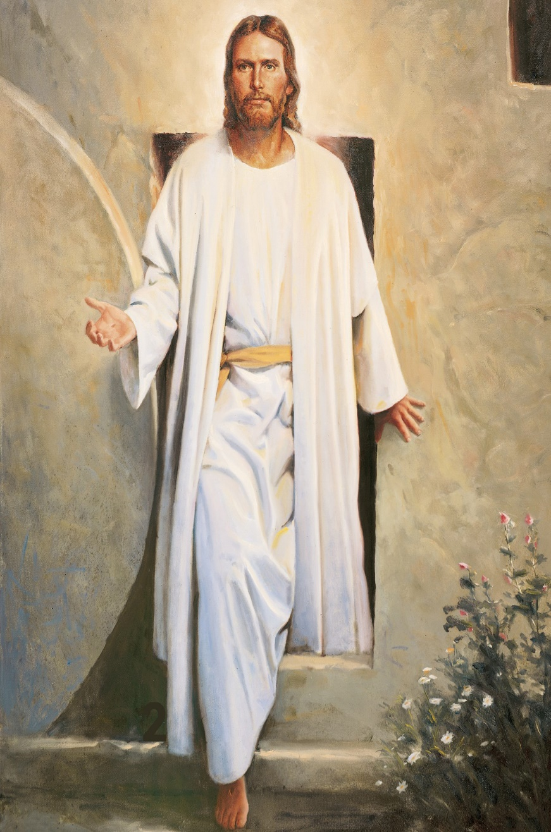
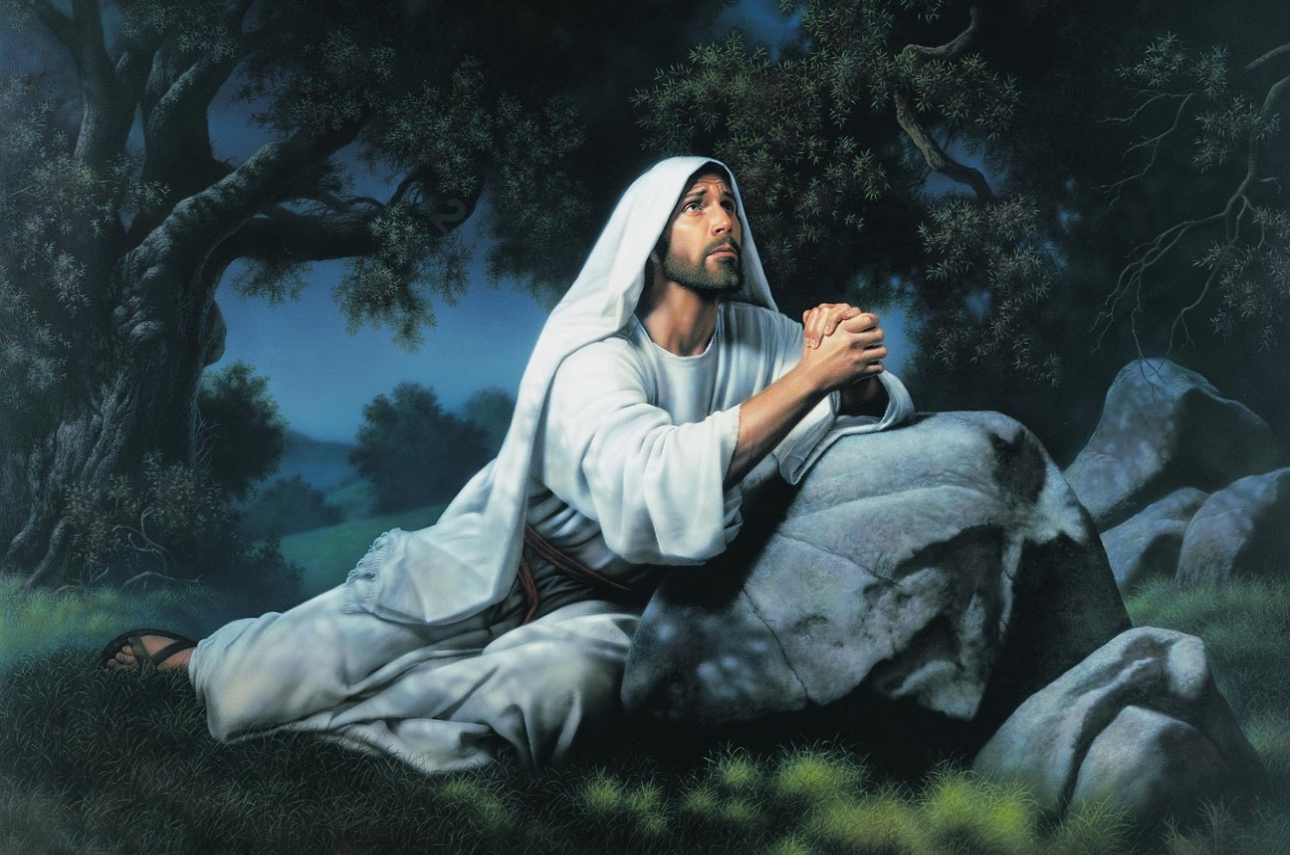

Host Sheet

Supplies per room:

- DM list
- 2 index cards (3, 15)
- 28 Puzzle pieces (25 DMs& 3 pics)
- Locked sign
- Scriptures (at least1 set)
- White board
- Box
- Lockbox
- Dry erase marker
- 5 Small Magnifying glasses
- 2 Combo locks
- Puzzle outline glass in frame
- Smartphone
- Table
- 4 Post-it Notes (J 7:17 w12, 2T 2:2 w17, J 1:5 w3, R 20:12 w11)
- 6 photos (birth of Christ, Woman at the well, Jesus heal the blind man, Jesus washes apostle’s feet, Garden of Gethsemane, Resurrected Christ)

Before Class:

- Place a picture, magnifying glass, index card (15) in box.
- Place “Locked” sign on box.
- Place puzzle piece, index card (3) in lockbox.
- Place 2 combo locks on the lockbox.
- Place a couple Bibles around the room.
- Place 4 Post-it notes around the room.
- Place 5 pictures around the room.
- Place 4 magnifying glasses around the room.
- Place 27 puzzle pieces around the room.
- Place table in middle of room.
- Put whiteboard in room.
- Put out dry erase markers.
- Place smartphone in room.
- Place box in room.
- Place lockbox in room.
- Place glass frame in room.
- Place DM list in room.
- Place “Story” in room.

Host Instructions:
- The Host is in the room to help students with their escape room experience but not to solve the puzzles for them.
- Provide support/assistance as need but do not provide the answers. Instead try asking additional questions to help the students view the clues in different ways that might help them to reach the answer.
- Encourage students to work together to solve the puzzles.

Puzzle #1
Students will need to:
- Find the post-it notes with DM scripture references on them.
- Figure out that the post-it notes are DM references and the “w” followed by a number refers to a specific word in the verse.
- Figure out that for the words to make sense they need to be put in the order they appear in the NT.
- Figure out that the words reveal a sentence (“The word of God”).
- Figure out what the sentence is referring to (scriptures).
- Figure out that the word is the voice codeword that will open the box.
- Approach the box and say the correct word.

Host:
- When the students approach the box and say the correct word (scriptures) open the box for them to reveal the next puzzle.

Puzzle #2
Students will need to:
- Remove the items (picture, magnifying glass, index card with a “15” on it) from inside the box.
- Find 5 other pictures and 5 magnifying glasses spread throughout the room.
- Figure out that the pictures need to be put in the order they happened in Christ’s life.
- Use the magnifying glasses to find the numbers hidden in the pictures.
- Figure out that the hidden numbers (152022) are a reference to 1 Corinthians 15:20-22 and are the combo to the combination lock on the box in the room. The first 3 numbers open the top lock, the last 3 numbers open the bottom lock.
- Use the code to up the lock and open the box.

Puzzle #3
Students will need to:
- Remove the items (puzzle piece, index card with a “3” on it) from inside the box.
- Assemble the puzzle
- Figure out that the easiest way to do so is put the DM topics together in order according to the DM list.
- Find the puzzle outline glass frame.
- Mount the puzzle on the glass in the frame.
- Figure out that there is a clue on the back of the puzzle (Phone Password Hint: James 1:5 FN A).
- Look up James 1:5 footnote A (D&C 42:68 & JS-H 1:11).
- Figure out that the footnote reference is the phone password (DC4268JSH111)

Puzzle #4
- Find the smartphone.
- Use the phone password to open the phone.
- Remember from the introduction that “most of the scripture” is in the Bishop’s “notes”.
- Open the “notes” app.
- Open the Interfaith Leadership Note.
- Retrieve the scripture from the notes (2 Timothy)
- Realize that the two numbers (15, 3) on the index cards are also part of the scripture reference.
- Look up the scripture.
- Call out the scripture (2 Timothy 3:15)
- Win!

Host:
- If the students have not won the room yet, provide a 10-minute warning at 6:30 and a 5-minute warning at 6:35 if necessary.
- Have students return to the gym at 6:40 even if they haven’t completed all the puzzles.

Answers:
Post-Its

- J 7:17 w2 (John 7:17) = The
- 2 T 2:2 w17 (2 Thessalonians 2:2) = Word
- J 1:5 w3 (James 1:5) = Of
- R 20:12 w11 (Revelation 20:12) = God

Pictures
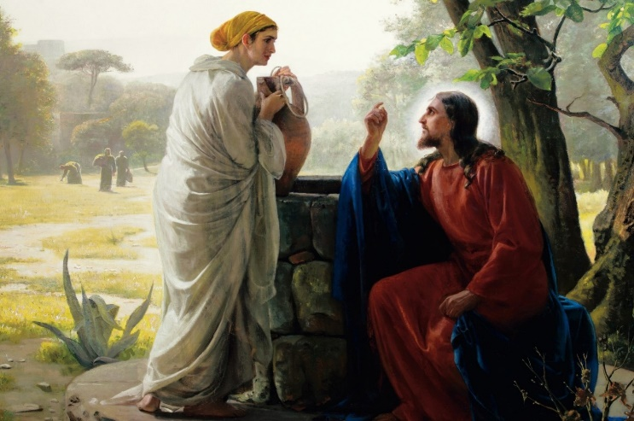

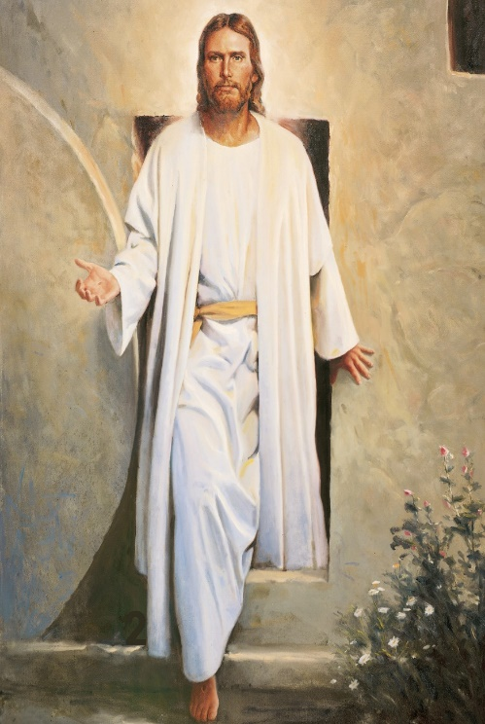
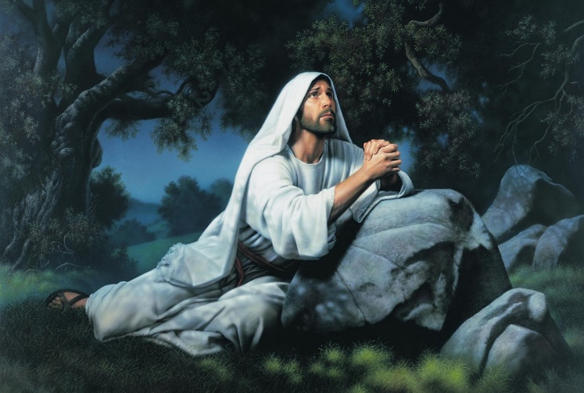
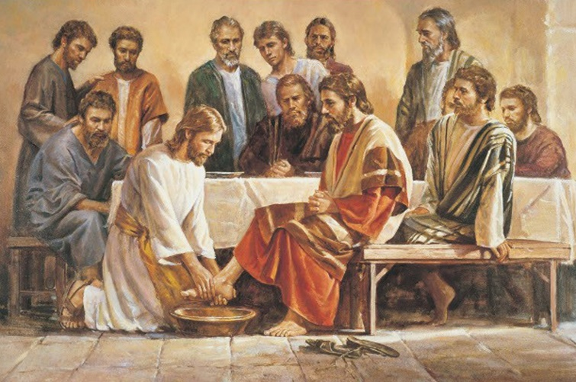
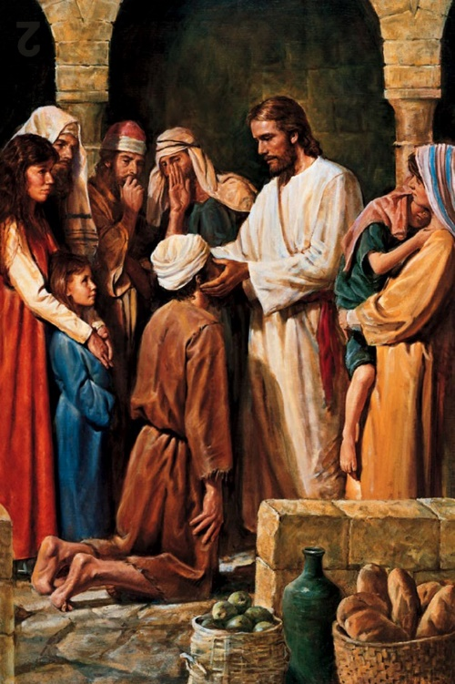

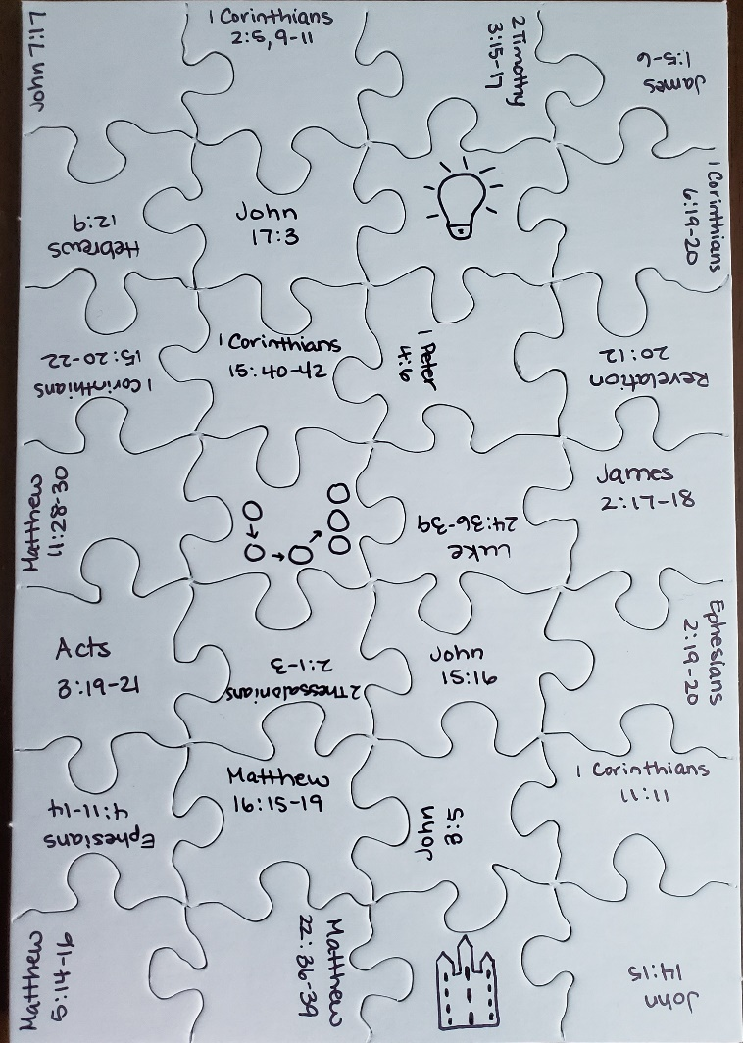
Puzzle
