Deliverance in the wilderness – a BREAKOUT experience
Setup: put up pictures of scenes from Nephi 1-22, set out a Master set of scriptures with the QR code folded up and placed in 1 Nephi 3:7. I changed the code on an IPAD to 5731. When the game begins I started a timer and the first team to get the correct code will stop the timer. The groups work best with between 4-7 players per team. Make as many copies of materials as you need per team.
Rules: Each team has 3 Hints. Each hint costs time the first hint = 1 additional minute, second hint = 2 minutes, third=3 minutes added on to their time at the end of the game.
“As the best pizza delivery service in the Land of Jerusalem, you’re known for making deliveries in record time. If it hadn’t been for your camel being on empty you would have definitely been to Lehi’s tent in time for the weddings. As it is you’re a day late and a few gold and silver short. You’ll need to find where the family has wandered off to in 30 minutes or less or the pizza will be free. You’ll have to snoop around their tent to find your next clue.”
Deliverance in the Wilderness Flow Chart (30 Minutes 5 Clues)
- Find the Newspaper in Lehi’s empty Tent
- Use the Jerusalem Times Crossword puzzle to solve a combination lock box. I used 3 separate boxes and my combination had to do with letters. I actually used a capsule from my daughters LOL doll. The highlighted numbers from the newspaper told the students what letter was a part of the combination. It would work just as well numerically.
    - 8 and 12
    - 2 and 5
    - 10 and 2
- Inside the combination boxes will be the pieces for the puzzler.
- The solution for the Puzzler is “TREE of LIFE”
- Students will need to turn over the pictures of the tree of life to find a codex on the back. If they turned over the incorrect pictures there are time deductions unless they sing “Book of Mormon Stories” with all the actions.
- Using the Jerusalem Times noticing the Tentworld advertisement with capital AK. When you line the A from the outer ring with the K from the inner ring it creates a code that will solve the scrambled journal entry in the newspaper to read:
“And it came to pass that I, Nephi, said unto my father: I will go and do the things which the Lord hath commanded, for I know that the Lord giveth no commandments unto the children of men, save he shall prepare a way for them that they may accomplish the thing which he commandeth them.”
- The second line of the advertisement gives the direction to look up the number.
- Students will need to look up 1 Nephi 3:7 and find the QR code in the reference.
- The QR code: https://www.youtube.com/watch?v=wK1ZPwi_sZs redirects you to a summary of President and Sister Nelson’s Call to the Youth Battalion.
- The code is taken from President Nelson’s advice to the youth: 5731
  - (5) things to change the world
  - Hold a (7)day fast on social media
  - Weekly sacrifice of time to the Lord (3) weeks in a row
  - Give to a friend (1) copy of For the Strength of Youth
Across |  | Down
3. Law | 10. commandment | 1.Gold | 8. prophets
4. records | 13. tent | 2.Fled | 9. father
7. Nephi | 15. Zoram | 3.Laban | 11. nation
 |  | 5.spirit | 12. plates
 |  | 6.wilderness
Murder’s diary entry found near victim’s body. An apparent diary entry was found near a beheaded body last month. Authorities have yet to discover the key that might be the break they’ve been looking for in solving this case.
Kxn sd mkwo dy zkcc drkd S, Xozrs, cksn exdy wi pkdrob: S gsvv qy kxn ny dro drsxqc grsmr dro Vybn rkdr mywwkxnon, pyb S uxyg drkd dro Vybn qsfodr xy mywwkxnwoxdc exdy dro mrsvnbox yp wox, ckfo ro crkvv zbozkbo k gki pyb drow drkd droi wki kmmywzvscr dro drsxq grsmr ro mywwkxnodr drow.

Jerusalem Times

12 tribes refute dooms-day prophets
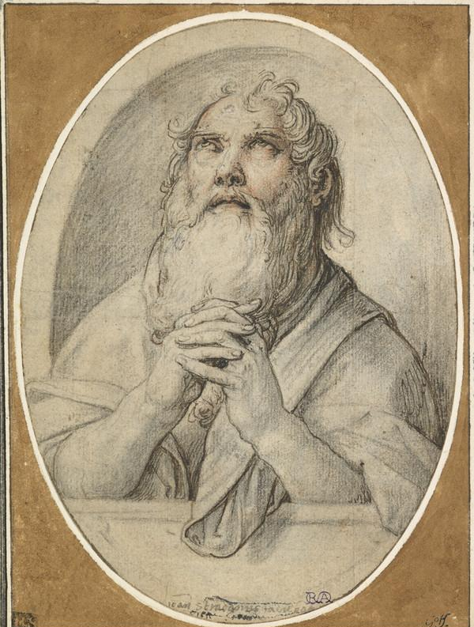
Jermiah praying 2 the God of Isreal.
M. Fiver
Jerusalem has been flooded with prophets predicting Babylonian overthrow of the city. First Jeremiah, the lamentor, was followed by Zenos and most recently Jerusalem’s own son Lehi.
When this reporter reached out for comment on this story Jeremiah was in jail and Lehi was no-where to be found. We are still bitter over his commentary and hope he is not doing gr8.

We’ve got your bAK!

You’ve got our number so look it up!
